Now this is one the beautiful technique which helps in making a model which is robust with outliers(i.e. which is not much affected by outliers).

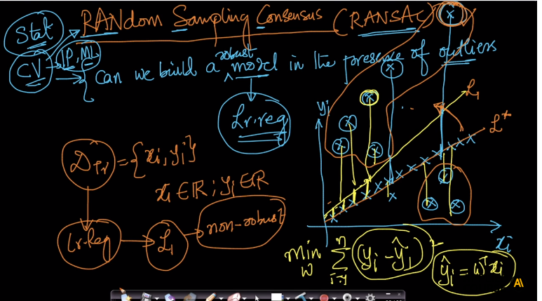

So suppose we have a LR model and we know how it behaves in case of outliers, the more extreme the outliers are the more they pull the plane from actual optimised

Plane towards them and that is what we call error. So as in above image because of extreme outliers on one side of plane the plane get shifted towards them which is yellow plane

And what was expected plane is depicted with orange color.

So RANSAC helps in making this models more robust.

Now what we do in RANSAC is we randomly sample 50% of data from original data where we might get few outliers than we were getting in whole data .

And then train model on that data say Dtr and and since we have fewer outliers so the plain will get less impacted from outliers and we will get less shifted plain as shown in below image by green line.

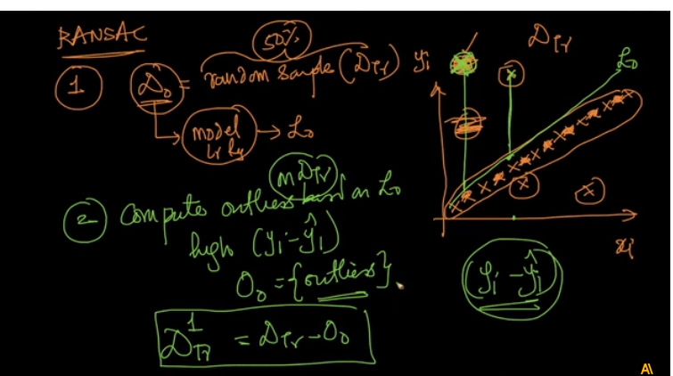

Now 2nd step is to compute outliers i.e. we will compute Yi-Yi(hat) and for those points where value is high for Yi-Yi(hat) will consider them as outliers say O.

And after computing outliers we can then form another data set Dtr – outliers(O).

And train our model again on this new model.

Now we will repeat step 1 and 2 and again take new sample and find new set of outlier sa O1 and then again train new set say Dtr1 .

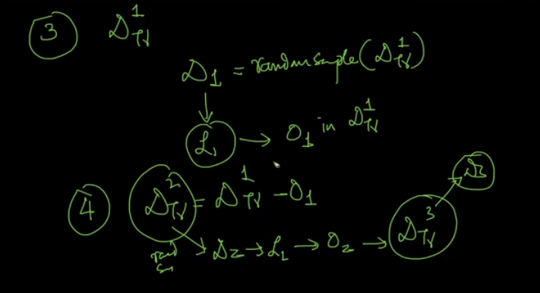

Now we keep doing this until we get two consecutive model that are almost similar as shown below.

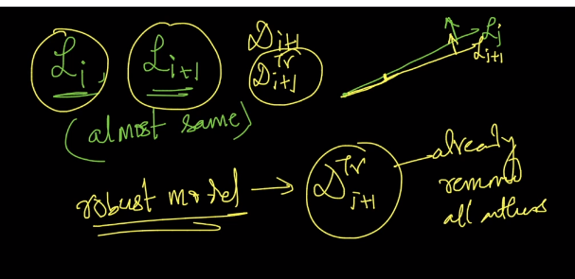

**Comments:**

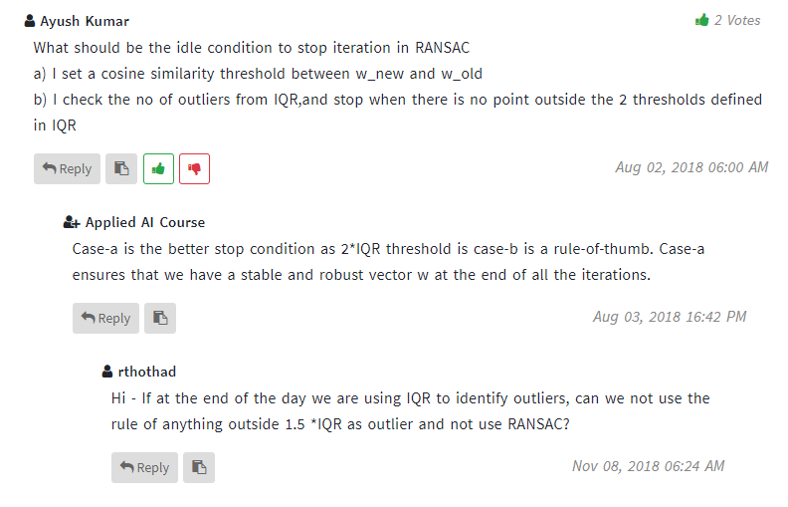

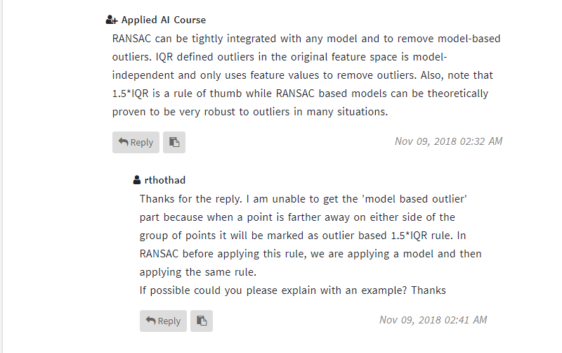

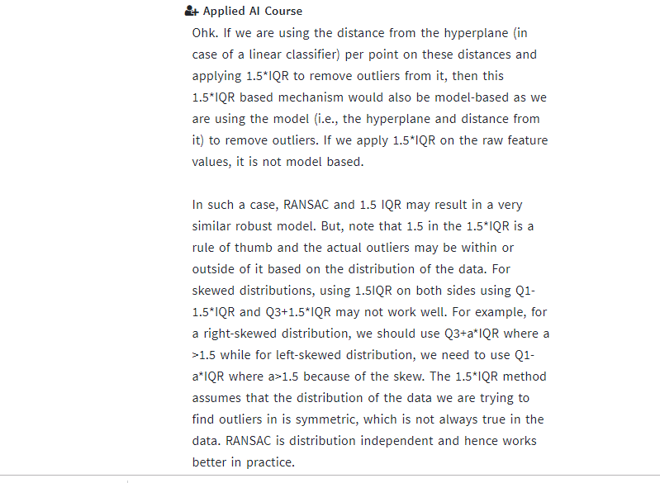

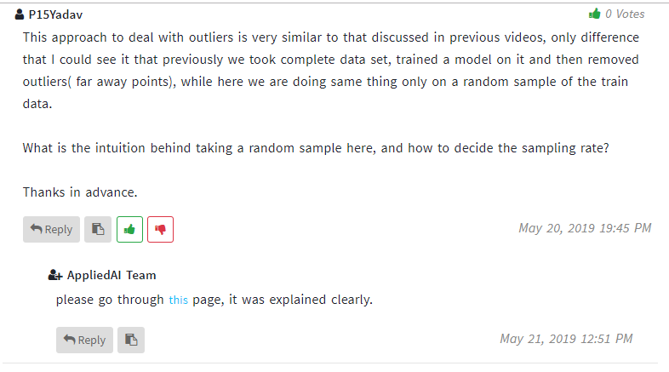

<https://en.wikipedia.org/wiki/Random_sample_consensus>